Instructor: Professor Christy Lynch

Office: GW-500

Office Hours: T/Th via Zoom appt
12:30 to 1:30

Class Meeting Day & Time
T/R 1:30p - 5:00p (Zoom)

Office Phone: 504.314.7921 but use email Rarely in my office

E-mail: clynch8@tulane.edu

Canvas: https://tulane.instructure.com/courses/2235513
https://tulane.instructure.com/courses/2235512

Class Location: Online

Course Description
ACCN 3010 examines how managers use accounting information to formulate plans, control operations and make informed managerial decisions. Students will learn cost behavior and how to use cost information in managerial decisions. Students will also learn how to develop a corporate budget and gather feedback to ensure that the budget is either properly executed or adjusted.

Course Prerequisites
Prerequisite: ACCN 2010

BSM Program Learning Outcomes
- Information Technology Goal: Freeman BSM students will be able to use technology to gather, manipulate, and analyze reliable data for business decision-making.
- Communication Abilities Goal: Freeman BSM students will be effective oral and written communicators.
- Discipline-Specific Knowledge Learning Goal: Freeman BSM students will have an understanding of core business theories and analytical and quantitative techniques in Statistics, Finance, Accounting, Management, Marketing, and Business Law.
- Social Responsibility Learning Goal: Freeman BSM students will have the business decision-making skills necessary to identify the relevant issues in a decision. Students will have the discernment to determine the primary stakeholders and to apply business theories, ethical theories, moral theories, and the law to produce socially responsible decisions.

Course Goals
This course is designed to teach you the uses of accounting information for both planning and control of business organizations, which help managers achieve organizations’ strategic objectives. A major goal of the course is to develop your understanding of the relevance of accounting to internal management, from the procedures used to generate accounting data through to the types of analyses required to effectively use the information for managerial decision making. The topics of the course, especially opportunity costs, relevant costs, and other analysis techniques, are directly and immediately relevant to not only your professional careers, but also your personal success. We will also emphasize cost accounting and financial reporting of inventories for manufacturers.

Student Learning Objectives
As the result of this course, students should be able to:
- Understand how costs flow through organizations, and how costs are accumulated and reported
- Use these costs and associated revenues to make decisions about the best level of operations
- Prepare a budget
- Compare actual results to budgeted results and evaluate performance
- Use appropriate relevant costing data to analyze business decisions such as outsourcing and pricing,
- Evaluate the results of these decisions

Course Material
- Each day at the beginning of class
  - Sign into Canvas and launch class Zoom link
  - Sign into NumberKnowledge to find your lecture notes

Below is a description of how our course is organized and an explanation of each website.

- Tulane’s Canvas for
  - Link to Class Zoom page and password for access as well as Zoom recordings
  - Link to my office hours and password for access
  - Announcements
  - Grades.
  - Class specifics such as the syllabus, schedule, class structure, etc.
- NumberKnowledge.com – Our Course website
  - The case sensitive password is TUL3010Learn
  - All Lectures
  - All Post Lecture videos – Quick videos produced by me explaining the most complex materials in the lecture series. Can be used to reinforce learning and test preparation.
  - Permanent links to syllabus, schedule, homework site, and other class specifics
- Connect – Our publishers website
  - We will use the ebook of our textbook in the Connect system. Our book is the 17th edition of Garrison’s Managerial Accounting. The bookstore will have the access code to purchase Connect. You may wish to purchase a hard copy in an older, less expensive edition for your accounting library.
  - If you have not already paid for Connect access, you should sign up and pay for access before the first day of class. You can sign up for 14-day free access but must pay on the 15th day.
  - Houses all graded and extra credit assignments (Please see the schedule)
    - Generally, unless otherwise noted in the schedule. Pre-Lecture Assignments are due by the beginning of class
    - Generally, unless otherwise noted in the schedule. Homework, Projects, and Quizzes are due by 10pm
  - Houses all tests
  - One of your first assignments will be to watch an overview video on Managerial Accounting and pay for proctoring services for your semester tests. The cost is $15. Please pay for this before your first test as you do not wish to lose precious test time paying for the service.
  - Houses all test prep materials in the Test Prep folder. These are prior assignments you can use to prepare for tests.
  - You may always work ahead of an assignment due date. However, assignments are due when indicated on the schedule.
- You should expect to use a calculator for your test, and one is also provided with the testing system. Also, you may use blank paper and should show the camera the paper is blank if you are taking a test outside of the classroom. The testing system also provides a white board.

Evaluation Procedures and Grading Criteria
This course follows the faculty approved grading guidelines of a maximum class average GPA in the range of 2.700 to 3.000 for core classes and a maximum class average GPA in the range of 3.000-3.333 for business elective classes. Please note the stated average class GPA range is a maximum average range and the class average GPA range could be lower.

Grade | A | A- | B+ | B | B- | C+ | C | C- | D+ | D | D- | F
Points | 100-  94 | 93-  90 | 89-  87 | 86-  83 | 82-  80 | 79-  77 | 76-  73 | 72-  70 | 69-  67 | 66-  63 | 62-  60 | 59-  or less

Grade Breakdown:
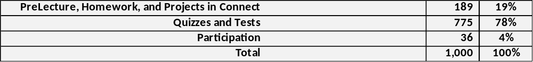
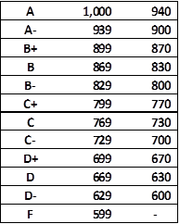

Course Policies

- ADA/Accessibility Statement
Tulane University strives to make all learning experiences as accessible as possible. If you anticipate or experience academic barriers based on your disability, please let me know immediately so that we can privately discuss options. I will never ask for medical documentation from you to support potential accommodation needs. Instead, to establish reasonable accommodations, I may request that you register with the Goldman Center for Student Accessibility. After registration, make arrangements with me as soon as possible to discuss your accommodations so that they may be implemented in a timely fashion. Goldman Center contact information: goldman@tulane.edu; (504) 862-8433;
https://accessibility.tulane.edu/

- Attendance Statement

If a student cannot attend a class for any reason, the student is responsible for communicating with their instructors to make up any work they may miss. If your reason for missing class is beyond ordinary circumstances, please contact Student Affairs to obtain a lengthy extension.

An instructor may have a student who has excessive absences involuntarily withdrawn from a course with a WF grade after written warning at any time during the semester.

The online option for this course is Zoom. Please note the Zoom rules below. You must

  - Have your camera on
  - Attend class in an environment that is not distracting to you or your classmates
  - Sit at a table or desk (do not sit on a couch or a bed)
  - Wear clothing that you would typically wear to class
  - Actively participate in class (that means you have read and contemplated the material assigned for that class, including the cases and completed all online or other exercises) and participate in class discussions
  - Attend the class for the entire class period

- Canvas – Please see above how Canvas will be used in this course.

- Code of Academic Conduct
The Code of Academic Conduct applies to all undergraduate students, full-time and part-time, in Tulane University. Tulane University expects and requires behavior compatible with its high standards of scholarship. By accepting admission to the university, a student accepts its regulations (i.e., Code of Academic Conduct and Code of Student Conduct) and acknowledges the right of the university to take disciplinary action, including suspension or expulsion, for conduct judged unsatisfactory or disruptive.

Unless I indicate differently on instructions, all assignments and exams are to be completed individually and without any study aid, including textbooks, class notes, or online sites. If you have any question about whether a resource is acceptable, you must ask me rather than make an assumption.

All tests will use Connect’s Proctorio software to monitor academic conduct.

- Course Structure
Grade challenges: Grades must be challenged within five (5) business days of the test; otherwise, the grade will not change.

After each test, your total grade will be updated.

There are no extra points available for this course unless provided by me. Please see your course schedule for extra point opportunities.

Goldman center eligible students will have separate tests in Connect—one for 1.5 time and another for 2.0 time. Please interact with Goldman to be accepted for accommodations.

Disruptive Behavior: Disruptive or disrespectful behavior is not allowed in class and will not be tolerated. I define any such behavior. Any instances will require a meeting between us, and you must meet with me before you return to class, or you will be asked to leave class until we have met. Disruptive behavior will affect your overall grade.

Communication: The best way to reach me is by email which is forwarded to my personal phone. Be sure to reference your class meeting days and times as I teach several sections.

Syllabus Changes: Circumstances may warrant additions or clarifications to the Syllabus for anything except your grade determination. I reserve the right to make any changes.

Tests: While homework and class time prepare you for the tests—tests are based on higher, more cognitive learning beyond rote memorization. You will be expected to tie concepts together to answer questions posed in an unfamiliar manner. You will be given all information to answer competently but your mastery of the topic is being tested. Your tests are not like your homework.
- Exams and quizzes will consist exclusively of multiple-choice questions with four answers or true/false questions. All materials discussed in class, whether in the text or not, will appear in examinations. All material in the lecture notes is considered when preparing tests.
- Bring a calculator, pencil, eraser, scratch paper, and a charger for your device.
- You should not expect to ask questions during an exam unless related to an unfamiliar word. My typical response to a test question is “I am testing whether or not you know this.”
Graded assignments in Connect
Class will move very swiftly. Please be certain to rely on the pre-lecture materials, read your notes, or watch the post lecture videos in NK or you will feel at a loss.

Homework and project work in Connect is due when indicated. If there is a conflict between the syllabus published schedule and any other source, the syllabus published schedule prevails.

Be certain to rely on the class schedule and not Connect to determine when assignments are due.

Pre-Lecture Assignments: There are pre-lecture assignments to be completed before class and are part of your homework grade. All chapters have pre-lecture assignments. These are usually quick videos from your book publisher with some elementary questions on the video. You have unlimited attempts.

Homework: You will have unlimited attempts. Only your highest attempt will count. Homework, assignments and projects are due when indicated. Late submissions are not accepted unless there is documented case with Connect, your internet provider, or student affairs. Please do not wait until the due date to try to complete the homework. The link to sign up for homework is in Canvas and NK.

If you are having any difficulty with a problem, send me a screen snip so I can help you quickly. Screen snip instructions are in NK.

PLEASE NOTE: Only Connect can solve system problems, contact them at 800-331-5094

In Connect, submit your work to have it preserved. DO NOT SAVE AND EXIT.

Connect does not work well with Internet Explorer.

Post-Lecture: These are YouTube videos prepared by me covering the more complex lecture topics. Use these to study for tests and to prepare for class.

Connect Practice Sets: In addition to homework, there are practice sets that mirror the pre-lecture and homework assignments. These will not close until the end of the semester. Use the practice sets to study for tests. They are located after graded homework in Connect and have a barbell icon.

Emergency Preparedness & Response

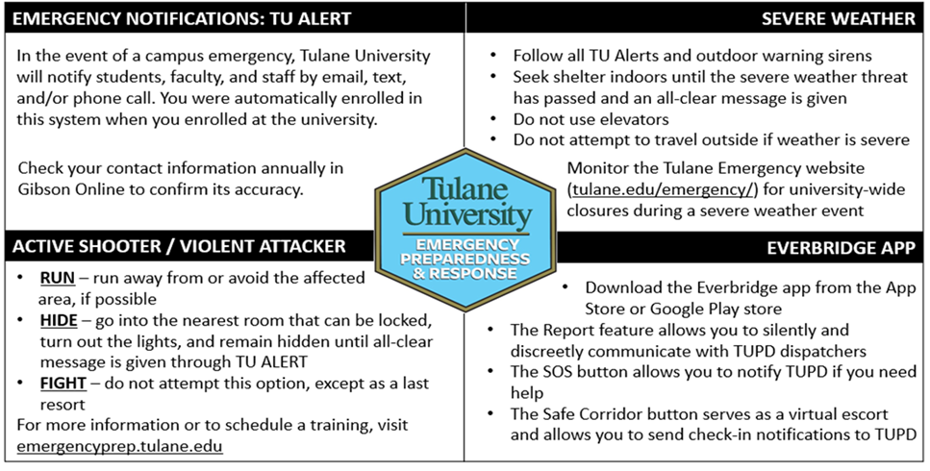

- Freeman Educational Norms and Expectations
This class is in full accordance with Freeman's Educational Norms and Expectations.

- Make-Up Exam Policy
If you miss a test, your final test will be a comprehensive final instead of a chapter test.
If you miss a second test, the grade for your second, missed test is a zero.

- Office Hours
Tuesdays and Thursday via Zoom appointment from 12:30 to 1:30

- Participation
Participation is graded and attendance is taken. Your attendance grade is affected by your good faith effort to participate. This is a highly interactive class, and you will be called upon to solve problems based on the preceding lecture material.

If you have a significant event (other than normal illnesses), you must contact the office of student services to process the event. They will contact me to provide you with any necessary extensions. Otherwise, you are expected to complete all assignments as outlined in the class schedule.

- Recordings of class sessions
Recording class sessions: Classes will be recorded, and the recordings will be posted to Canvas. Students may not post a class recording elsewhere, either wholly or in part.

- Religious accommodation policy
Per Tulane's religious accommodation policy, I will make every reasonable effort to ensure that students can observe religious holidays without jeopardizing their ability to fulfill their academic obligations. Excused absences do not relieve the student from the responsibility for any course work required during the period of absence. Students should notify me within the first two weeks of the semester about their intent to observe any holidays that fall on a class day or on the day of the final exam.

- Title IX
Tulane University recognizes the inherent dignity of all individuals and promotes respect for all people. As such, Tulane is committed to providing an environment free of all forms of discrimination, including sexual and gender-based discrimination, harassment, and violence like sexual assault, intimate partner violence, and stalking. If you (or someone you know) has experienced or is experiencing these types of behaviors, know that you are not alone. Resources and support are available: you can learn more at allin.tulane.edu. Any and all of your communications on these matters will be treated as either "Confidential" or "Private" as explained in the chart below. Please know that if you choose to confide in me, I am mandated by the University to report to the Title IX Coordinator, as Tulane, and I want to be sure you are connected with all the support the University can offer. You do not need to respond to outreach from the University if you do not want. You can also make a report yourself, including an anonymous report, through the form at tulane.edu/concerns.

Confidential | Private
Except in extreme circumstances, involving imminent danger to one’s self or others, nothing will be shared without your explicit permission. | Conversations are kept as confidential as possible, but the information is shared with key staff members so the University can offer resources and accommodations and take action if necessary for safety reasons.
Counseling & Psychological Services (CAPS) | (504) 314-2277 or  The Line (24/7) | (504) 264-6074 | Case Management & Victim Support Services | (504) 314-2160 orsrss@tulane.edu
Student Health Center | (504) 865-5255 | Tulane University Police (TUPD) | Uptown - (504) 865-5911. Downtown – (504) 988-5531
Sexual Aggression Peer Hotline and Education (SAPHE) | (504) 654-9543 | Title IX Coordinator | (504) 314-2160 or msmith76@tulane.edu



