Instructor: Christy Lynch, CPA, CFE, MSA

Office: GW500

Office Hours: Zoom Appt MW 12:45-1:45

Course Meeting Day & Time: MW 9:30-10:45
Office Phone: 504.314.7921 (rarely used)

E-mail: clynch8@tulane.edu

Canvas Site: Link to Site

Course Location: GW280

Course Description: This course covers principles that govern the reporting of assets, liabilities, revenues, transfers, expenditures, gains, losses, and net assets of governmental and not-for-profit entities. Discussion of the theoretical underpinnings of these principles, as well as the ‘disconnects’ still present in governmental principles vs. ‘for profit’ principles, will be included in this course.

Course Prerequisites: ACCN 6010 or equivalent

Course Goals:
This course is designed to teach students the elements of fund accounting and the reasons for its use in governmental and not-for-profit entities.

Student Learning Objectives:
As the result of this course, you will understand how the different operating purposes, goals, objectives and requirements for governmental and not-for-profit entities influence the accounting methods used. You will be able to critically assess the accounting for both public (governmental) and private not-for-profit entities such as health care organizations and colleges and universities.

Course Structure:
Students are expected to prepare for class by completing pre-lecture assignments based on chapter readings. Class will be comprised of interactive lectures with in-class problem solving. Participation is not graded but is required.

Each day, sign into Canvas, launch Zoom, and then launch your notes from NumberKnoweldge.com

Course Material:
Required Text:
Essentials of Accounting for Governmental and Not-for-Profit Organizations by Paul A Copley, 14th ed. You need not purchase the book. We will use my notes published in a website I have created entitled NumberKnowlege.com The password for the class is case-sensitive TUL7420Learn

We will use the homework management system (Connect) extensively for this class; therefore, I require you to purchase Connect access for this class. This will also give you access to the ebook. We will sign into Connect if you have a pass code, purchase it, or request the free trial during the first day of class.

You will be responsible for true/false pre-lecture assignments which will require you to read the book chapter before class. Your homework will be comprised of multiple-choice questions from reading the chapter as well as lengthier exercises we will often review in class.

Class Supplies:

You should bring a laptop or iPad device to read your notes in class but not a phone. Please stow your phones during class. If I see your phone out, I may be tempted to take it and give it back to you after class. Simple calculator, mechanical pencil, a white polymer eraser, and notebook.

NOTE: I reserve the right to amend this syllabus as needed to add clarification and/or change policies given the fluidity of COVID status. The only item that will not change is your grade determination of points assigned to activities and overall points.

Evaluation Procedures and Grading Criteria:

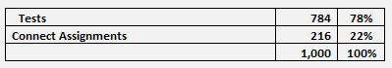
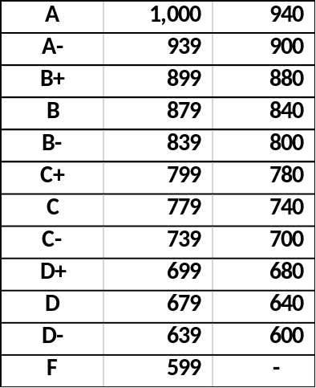

Grade Symbols: All graduate programs in the Freeman School use a letter grade system with the following quality point equivalents:

A | = | 4.00
A- | = | 3.67
B+ | = | 3.33
B | = | 3.00
B- | = | 2.67
C+ | = | 2.33
C | = | 2.00
C- | = | 1.67
D+ | = | 1.33
D | = | 1.00
D- | = | 0.67
F | = | 0.00

The quality point total for each course is computed by multiplying the numerical value of the grade received by the course credit hours.

Grading Guidelines: The Freeman School faculty approved the recommended grading policy for a class GPA by program. 6000-level courses are expected to have a mean class GPA in the range of 3.00 to 3.33. 7000-level courses are expected to have a mean class GPA in the range of 3.33 to 3.67.

Grade challenges: Grades must be challenged within five (5) business days of the test; otherwise, the grade will not change.
The GPA class average allowed by The Freeman School policy for 7000 level graduate courses is 3.33 to 3.67 (B+ to A-). The class’s raw scores will be adjusted until the average grade for the course is consistent with this policy.

There are only three locations for a test. 1) In person/class 2) Goldman Center 3) Remotely—only for those on the approved extended absence list. If you do not automatically qualify for an extended absence, you must contact student affairs to request this status. This process is not automatic, and you may not be approved. This cannot be done retroactively but must be done before the test.
All tests taken remotely (not in person or through Goldman) will be different from in person/Goldman tests. These tests will have more questions to mitigate against the temptation to use resources other than allowed to in person/Goldman students.
If a student misses a test, they must take the final comprehensive exam. Students can only miss one test.
Students may take the final, comprehensive exam to improve their final grade but once a student has elected to do so, the decision is final.
Tests:
- There are practice sets in Connect which consist of your pre-lecture and homework assignments. Please use these to study for tests as they will remain open throughout the semester.

- Exams will consist exclusively of multiple-choice questions with four answers and perhaps some true/false questions. All material in the lecture notes is considered when preparing tests. Your tests will be on-line.

Your Connect assignments (pre-lecture and homework) are made of pool of the odd numbered assignments and lengthier exercises. Your test will be comprised of a pool of all the even numbered Connect assignments and the lengthier exercises.

- Bring a simple calculator, pencil, and eraser. You cannot use your phone as a calculator.
- Be sure your phone is off and put away in your bag. Ringing or vibrating phones are distracting to test takers and may result in a loss of points.
- Your book bags, purses, keys, phones etc. must be placed either at the front of the room or along the walls.
- You may not ask questions during an exam unless there is a word you do not understand.
- My aim is to post grades generally within two days of your tests or the due date of a project.

Problems with the Connect System: The help number for Connect is 1-800-331-5094. I cannot fix problems with the Connect system; you must call them. If there is a documented case problem with Connect or a documented internet outage, send me the documentation if you need an extension. Don’t wait until the last minute and say there is a problem with Connect. You must call them in sufficient time to iron out any problem. Connect works best with Firefox, Chrome and Safari.

Class Attendance/Participation:
Attendance is taken at the beginning of the semester to help me identify you. Attendance is not graded. If you miss a class, you are still responsible for the material and all lecture notes.
Studying for tests:
Everything in your notes and experiential learning will prepare you for your tests. There is nothing on your test which is not in your notes or something we did not cover in class.

What to expect in class:
I will refer to my lecture slides to deliver pertinent concepts. We will also work some of your homework assignments in class to aid in your ability to learn the material.

Class Communication:
I will use Canvas and email to communicate outside of class. Please check these often to remain abreast of changes. Please follow up any verbal communication with an email. I will be better able to remember our conversation if you send me a follow up email.

When you send me an email, use these instructions to prepare a screen snip which is easier to read than a screen shot.
Disruptive Behavior:
Disruptive or disrespectful behavior is not allowed in class and will not be tolerated. I define any such behavior. Any instances will require a meeting between us. You must meet with me before you return to class or you will be asked to leave class until we have met. Disruptive behavior will affect your overall grade.
Office Hours Policy:
By appointment in Zoom. This is the link to my personal zoom room The passcode is 30102021
Monday and Wednesday 12:45 to 1:45
Specific Course Policies:
- Canvas Use and Requirements
- Canvas will house permanent links, grades, university resources, and class basics.
- Your notes are housed in NumberKnowldge.com There is a case-sensitive password TUL7420Learn
- Graded assignments such as pre-lecture assignments, homework, and tests are housed in the Connect system.

- Class Attendance Policy
  - Attendance is highly encouraged for this hands-on learning environment. Attendance is not graded but passively watching on Zoom will not aid your understanding of the materials.

  - Students should make every effort to attend class in person unless qualified under the extended absence provisions in Gibson. If a student does not automatically qualify for an extended absence, they may contact student affairs to request an extended absence and be placed on the extended absence list. Such requests are not automatic and must be done ahead of class time. All students will be placed in the waiting room in Zoom and will be admitted if they are in person or on the extended absence list. Otherwise, students may view the zoom lecture when posted after class.

Recordings of Class Sessions
Classes will be recorded and posted in Canvas. Students are welcome to view Zoom recordings.

Statement about Academic Integrity:
This class will be conducted in full accordance with Tulane’s policies about academic integrity including, but not limited to, the Unified Code of Graduate Student Academic Conduct (https://ogps.tulane.edu/graduate-policies) and the Tulane University Code of Student Conduct (https://conduct.tulane.edu/resources/code-student-conduct).

Any member of the university community may file charges against a student for violations of the code. A charge shall be prepared in writing and directed to Associate Dean John Clarke at jfc@tulane.edu.

Norms and Expectations:
This class will be conducted in full accordance with published Norms and Expectations for Students in Freeman Classes. Please review the Norms and Expectations in your graduate program handbook which can be found on the Freeman School website https://freeman.tulane.edu/current-students.

Goldman Center for Student Accessibility and ADA/Accessibility Statement:
Under the Americans with Disability Act and Section 504 of the Rehabilitation Act, if you have a disability, you may have the right to an accommodation; however, the right is contingent upon your taking certain steps. You should review the steps that you need to take, as well as Tulane’s policy concerning accommodations at https://accessibility.tulane.edu/.

Any student with a disability, in need of course or examination accommodation, should request an accommodation through the University’s Goldman Center for Student Accessibility, located in the basement of the Howard Tilton Memorial Library. Visit http://accessibility.tulane.edu or call 504.862.8433 for more information.

At the beginning of the semester, please provide me with a copy of your approved accommodation form. I am committed to working with the Goldman Center to ensure that I provide you with all approved accommodations. If you do not deliver the approved accommodation form to me, I will not know that the Goldman Center approved your accommodation and I will have no basis to provide those accommodations.

Religious accommodation policy
Per Tulane’s religious accommodation policy, I will make every reasonable effort to ensure that students can observe religious holidays without jeopardizing their ability to fulfill their academic obligations. Excused absences do not relieve the student from the responsibility for any course work required during the period of absence. Students should notify me within the first two weeks of the semester about their intent to observe any holidays that fall on a class day or on the day of the final exam.

Discrimination and Harassment
Tulane University recognizes the inherent dignity of all individuals and promotes respect for all people. As One Wave, Tulane is committed to providing an environment free of all forms of discrimination and sexual harassment, including sexual assault, domestic and dating violence, and stalking. If you (or someone you know) has experienced or experiences gender-based violence, know that you are not alone. Learn more at https://campushealth.tulane.edu/well/one-wave.
Emergency Preparedness & Response
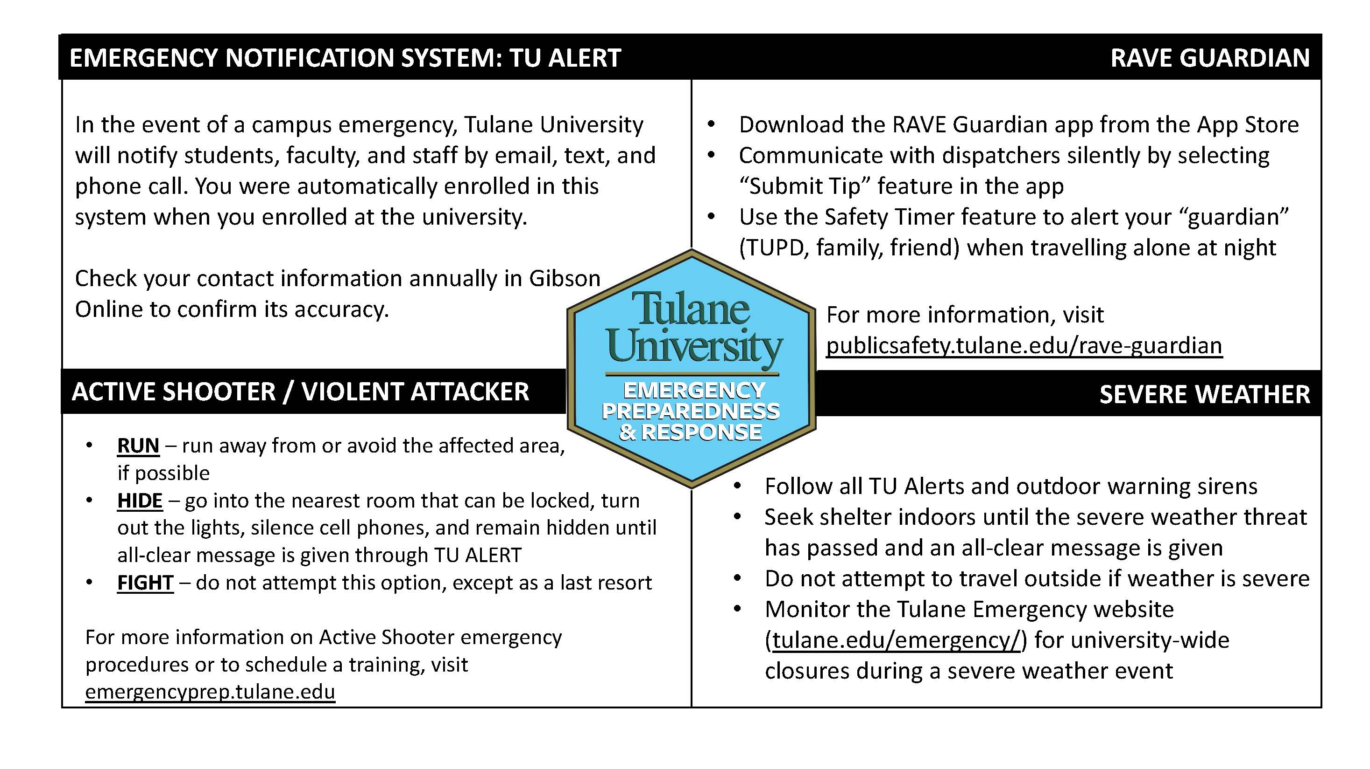
Title IX:
Tulane University recognizes the inherent dignity of all individuals and promotes respect for all people. As such, Tulane is committed to providing an environment free of all forms of discrimination including sexual and gender-based discrimination, harassment, and violence like sexual assault, intimate partner violence, and stalking. If you (or someone you know) has experienced or is experiencing these types of behaviors, know that you are not alone. Resources and support are available: you can learn more at allin.tulane.edu. Any and all of your communications on these matters will be treated as either “Confidential” or “Private” as explained in the chart below.

Please know that if you choose to confide in me, I am mandated by the university to report to the Title IX Coordinator, as Tulane and I want to be sure you are connected with all the support the university can offer. You do not need to respond to outreach from the university if you do not want. You can also make a report yourself, including an anonymous report, through the form at tulane.edu/concerns.

Confidential | Private
Except in extreme circumstances, involving imminent danger to one’s self or others, nothing will be shared without your explicit permission. | Conversations are kept as confidential as possible, but information is shared with key staff members so the University can offer resources and accommodations and take action if necessary, for safety reasons.
Counseling Center| (504) 314-2277 or  The Line (24/7) | (504) 264-6074 | Case Management & Victim Support Services | (504) 314-2160 or srss@tulane.edu
Student Health Center | (504) 865-5255 | Tulane University Police (TUPD) | Uptown - (504) 865-5911. Downtown – (504) 988-5531
Sexual Aggression Peer Hotline and Education (SAPHE) | (504) 654-9543 | Title IX Coordinator | (504) 314-2160 or msmith76@tulane.edu
Course Schedule:
Provide students with an outline of significant events that occur throughout the semester, including assignments, projects, examinations, field trips, guest speakers, etc..

Course schedules must follow either the Graduate Day or Evening Calendars, which are posted on the Freeman Graduate current students’ website (https://freeman.tulane.edu/current-students).


