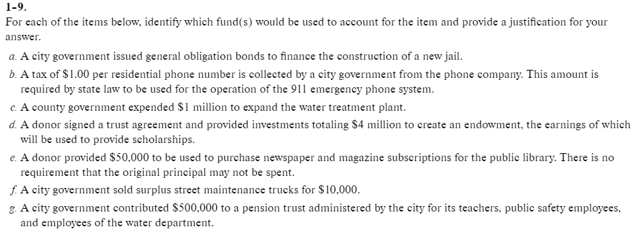
Your choices are:
- Private-purpose trust fund
- Enterprise fund
- Special revenue fund
- Capital projects fund
- General fund
- Permanent fund
- Or several funds including ???

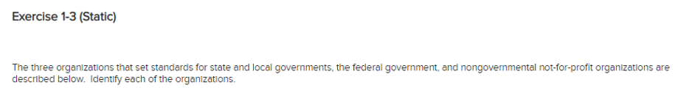
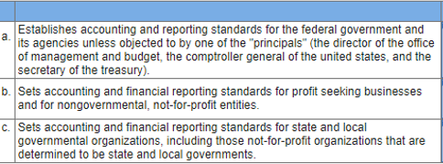
Your choices are:
- GASB
- FASB
- Federal Accounting Standards Advisory Board

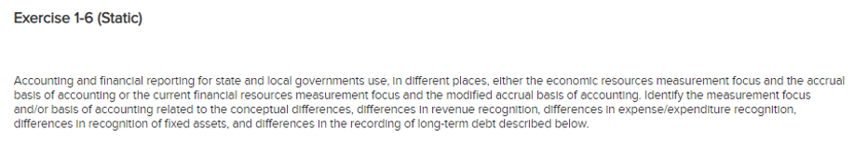
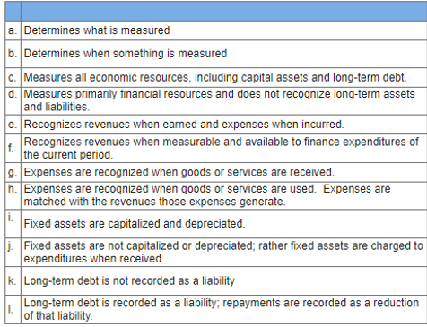
Your choices are
- Current financial resources measurement focus
- Accrual basis of accounting
- Measurement focus
- Economic resources measurement focus
- Modified accrual basis of accounting
- Basis of Accounting
- Economic resources measurement focus and accrual basis of accounting
- Current financial resources measurement focus and modified basis of accounting

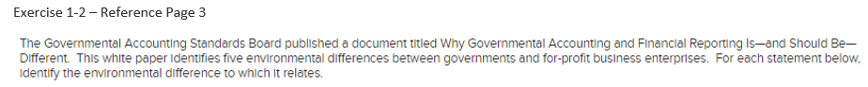
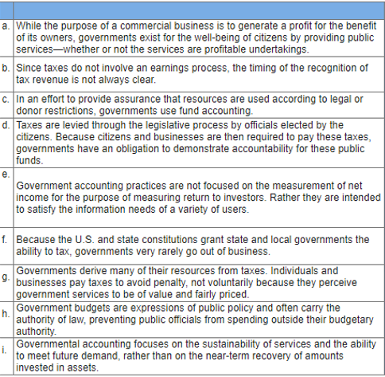

- Organizational Purposes: While the purpose of a commercial business is to generate a profit for the benefit of its owners, governments exist for the well being of citizens by providing public services – whether or not the services are profitable undertakings.

- Sources of Revenues: Governments derive many of their resources from taxes. Individuals and businesses pay taxes to avoid penalty, not voluntarily because they perceive government services to be of value and fairly priced. Since taxes do not involve an earnings process, the timing of the recognition of tax revenue is not always clear.

- Potential for Longevity: Because the U.S. and state constitutions grant state and local governments the ability to tax, governments very rarely go out of business. This long-term view of operations changes the focus of accounting from one of near-term recovery of amounts invested in assets to a longer-term focus on the sustainability of services and the ability to meet future demand.

- Relationship with Stakeholders: Taxes are created through the legislative process by officials elected by the citizens. Because citizens and businesses are then required to pay these taxes, governments have an obligation to demonstrate accountability for these public funds.

